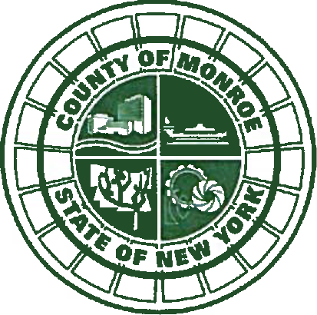
Office of the

Public Defender
Monroe County, New York

Adam J. Bello

County Executive

July 15, 2021
Timothy P. Donaher, Esq.

Public Defender

Ann M. Graham, Executive Director Reentry Association of WNY
71 Olde Tavern Circle Rochester, New York 14612

RE: Reentry Continuum of Care Pilot Progra.m

Dear Ms. Graham:

I write to enthusiastically endorse and support the Reentry Association of WNY's proposal to create a Reentry Continuum of Care Pilot Program to provide a single point-of­ entry for the formerly incarcerated who are returning to our community.

As you know, the reentry challenges facing the formerly incarcerated are formidable. The vast majority of people who are incarcerated are released back to their community; most are in need of services to ensure that they are able to successfully reintegrate and avoid recidivism. Unfortunately, despite available services, the formerly incarcerated are not provided the guidance they need to connect with services designed to address their unique issues. A single point-of-entry for the formerly incarcerated where they can be assessed for needs and connected to appropriate service providers would remedy this problem.

Additionally, the reentry service community needs an organization that can advocate for additional funding to improve services, and develop minimum standards for the provision of reentry services. The Reentry Association of WNY is uniquely positioned to provide those services, given your expertise and years of experience.

I support your efforts, and I will provide any assistance you need in developing and implementing the Reentry Continuum of Care Pilot Program.
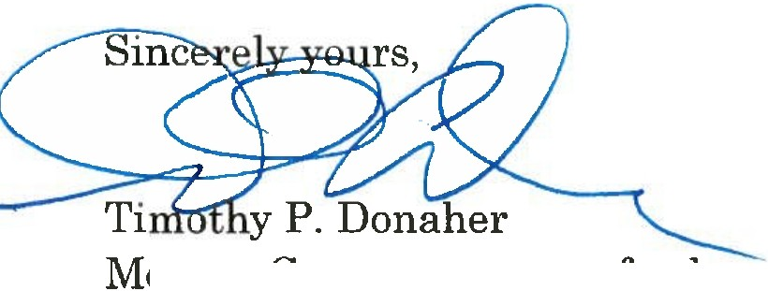

onroe Gounty Public Detenct.er

10 N. Fitzhugh Street• Rochester, New York 14614 (585) 753-4210 • Jax: (585) 753-4234 • www.monroecounty.gov

